WIE INSIGHT

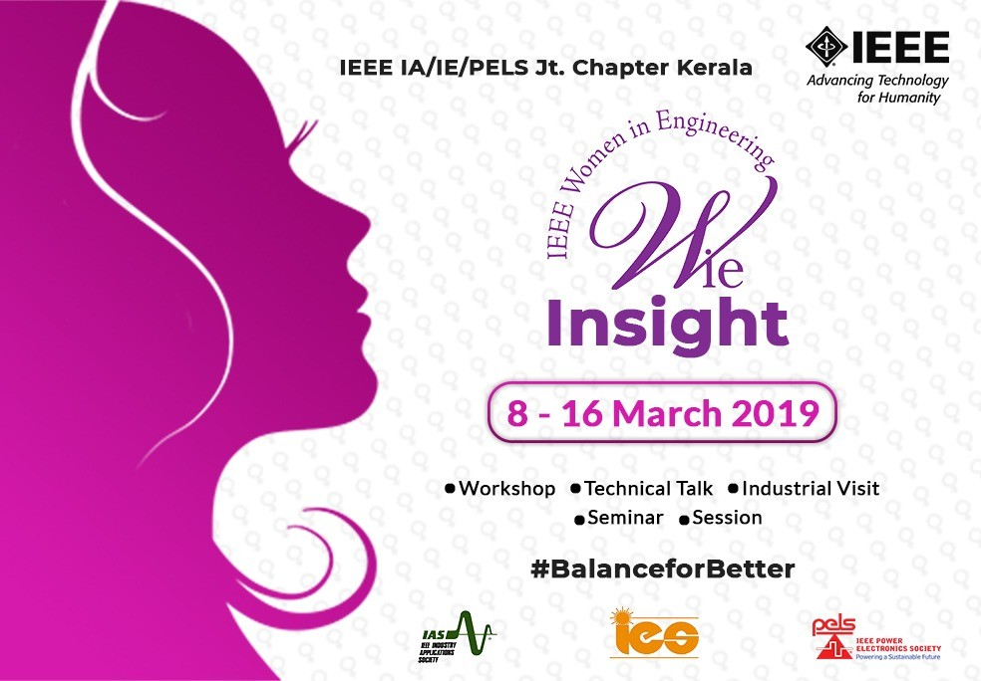
IEEE IA/IE/PELS Jt. Chapter Kerala celebrated the spirit of womanhood with" Wie insight"as a part of international women's day 2019 to tribute all women who brought phenomenal change in the society.The program was aimed to elevate the unlimited power of women in the context of science and technology.Wie insight conducted from March 8 to 16 was leaded by Athira.M (wie coordinator IA /IE/PELS Jt. chapter Kerala) and Laya Raj
( Tranvancore hub wie coordinator IA /IE/PELS Joint chapter Kerala ).About 25 events happened around Kerala as a part of Wie insight.The event aimed to build up a girl community of self confidence.The program mainly focused on benefits of girl student members in IAS,IES and PELS.The program helps to raise the voice of women empowerment and to break the shackles of exclusion.
The major activities conducted as a part of Wie insight was a photographic contest and a two level quiz competition naming Quest.The topic of the photographic competition was "Women's day celebration and Women empowerment".About 15 entries came for the competition around the

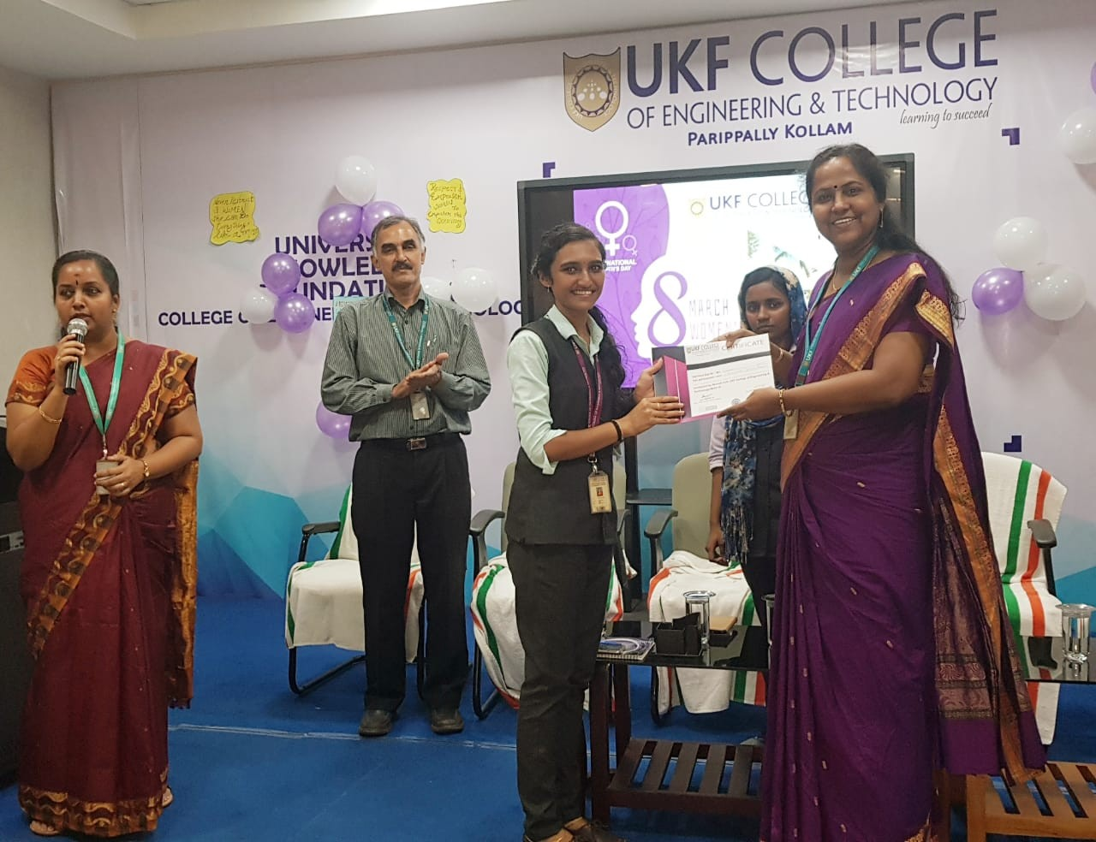
SBCs in Kerala.The validation of the competition was done by the excom members. The photograph from IAS SBC UKFCET is selected as the best among the entries. The prize is a SDLP session organised by joint chapter.
The next major event is the quiz naming "QUEST".The quiz competition (Quest) happened around 17 SBCs under joint chapter.The details of the winners were collected by the chapter chairs.The quiz is based on woman empowerment, science and technology.
The active participation of the SBCs under joint chapter made the event a grant success.The activities under wie insight help the girl students to realise their potential and innate their abilities.

