TRIAC- A Two day Workshop
IEEE IA/IE/PELS Jt.chapter, IEEE PES, & IEEE ComSoc Kerala Chapters jointly organized a 2 day workshop on relevant areas at Technical Revamping Initiative Aspired Concourse (TRIAC). The workshop was hosted by FISAT Engineering College, Angamaly from 26th to 27th October 2019.
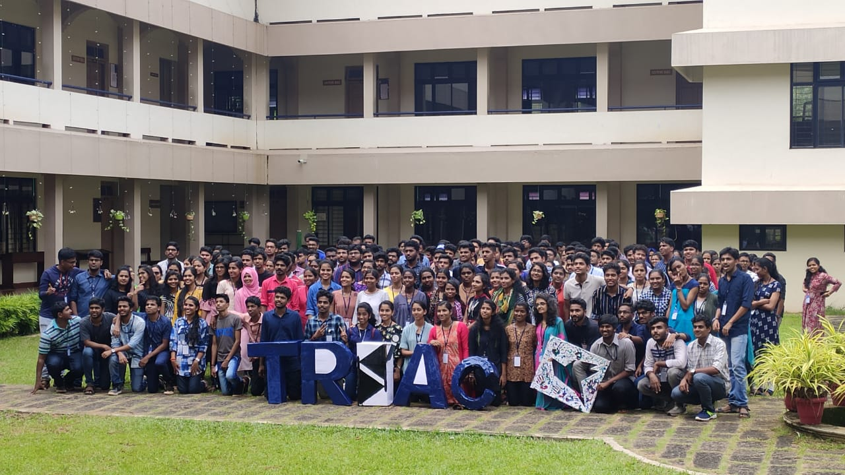
Group photo of participants
220 students from various engineering colleges across Kerala attended the programme.

