2 day Proficiency Programme on " ELECTRIC AND HYBRID VEHICLE
ENGINEERING”
The IEEE IAS SBC Saintgits college of Engineering in association with IEEE IA/IE/PELS Jt. Chapter Kerala conducted 2 day Proficiency Programme on " ELECTRIC AND HYBRID VEHICLE ENGINEERING” on 30 and 31 of August 2019. The programme was sponsored by IEEE Industry Applications Society. Dr.Pinkymol K.P (IEEE IA/IE/PELS Jt. Chapter Kerala Excom Member) and Mr.Abraham George (Counselor- IEEE SBC Saintgits) and Mr.Aravind Anil (Chair-IEEE IAS SBC) were the coordinators. The course was aimed to enhance the academic and professional skills of students, faculty members and other professionals. This workshop contained theory modules, practical and demo sessions to understand EV design and architecture which was followed in EV industry. Mr. P Prasanthkumar from Haritha TechLogix Pvt.Ltd , Bengaluru handled the training sessions. The main objective of the workshop was to give a brief overview about the electric and hybrid vehicles design and currently used technologies in the field. Modeling and simulation studies of Electric & Hybrid vehicle were performed in MATLAB/ SIMULINK environment. Case studies on the state-of-the- art technologies used and the improvements made in the design of both electric and hybrid vehicles were studied by taking examples from Chevrolet, Tesla, Toyota etc.
The training programme was attended by 60 participants which includes participation from 7 external colleges in Kerala. Prof.Biju K IEEE IA/IE/PELS Jt. Chapter Kerala, Secretary has also attended this two-day training programme. The participation details are given below.
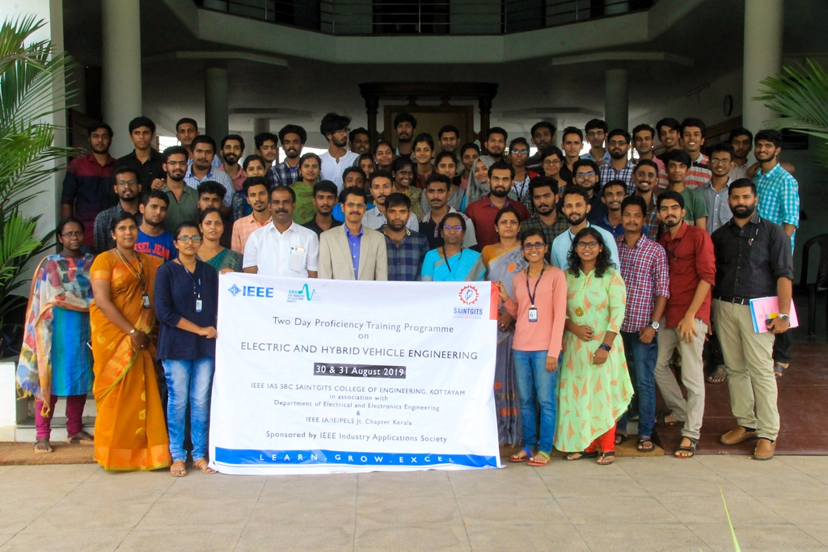
The number of participants for the programme was 60 including 28 IEEE members.

